# PARUL UNIVERSITY

**Parul Institute of Computer Application Basic Software Engineering – 05101253**

# Semester – 3

**Case Study Example: Online Library System (OLS)**

**Practical 6:** Creation of DFD’s (Data Flow Diagram)

**DFD:** A data flow diagram (DFD ) is a way of representing a flow of a data of a process or a system (usually an information system). The DFD also provides information about the outputs and inputs of each entity and the process itself. A data flow diagram has no control flow, there are no decision rules and no loops.

DFD takes an input-process-output view of a system. Data flow into the software & transformed by processing elements & resultant data flow out of the software.

**Example:** Every computer-based system is an information transform

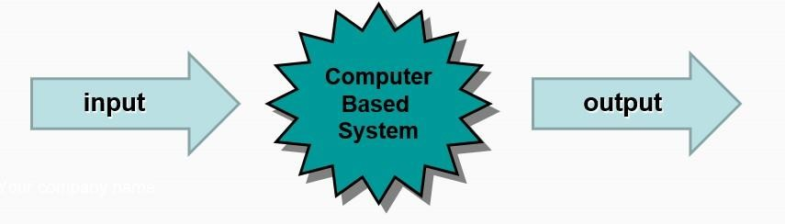

# DFD Notations:

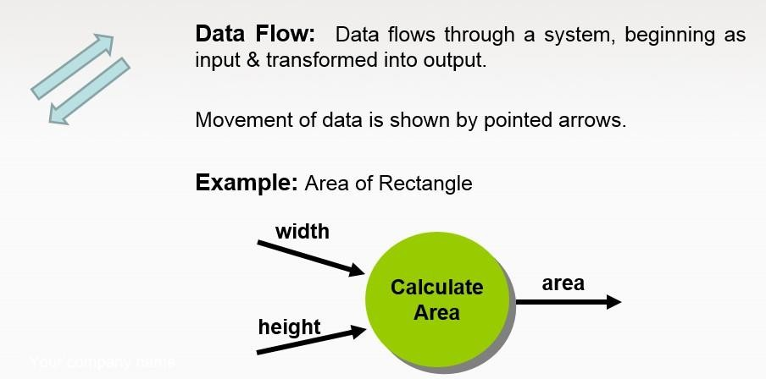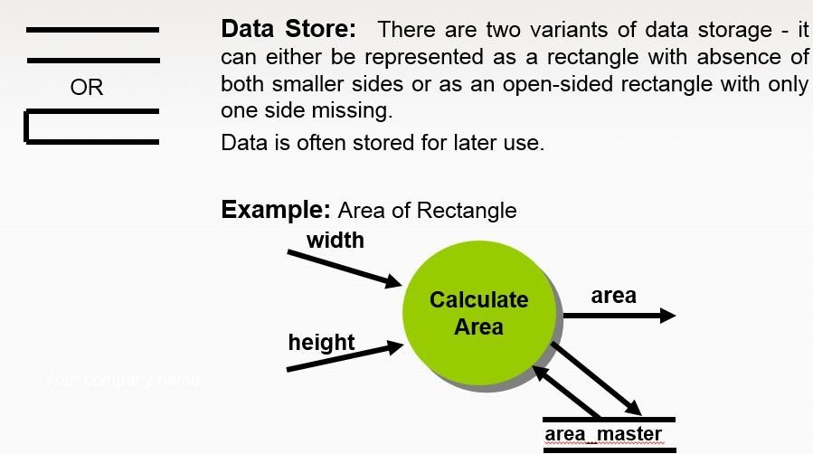

**Context Level (Level 0) DFD for OLS:**

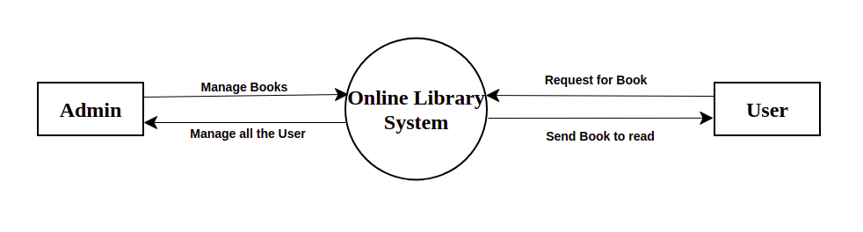

# Top Level (Level 1) DFD for **OLS**:

# 